**Assignment5**

**Creating the delta lake table**

We have to upload the file and have to create the datalake table.

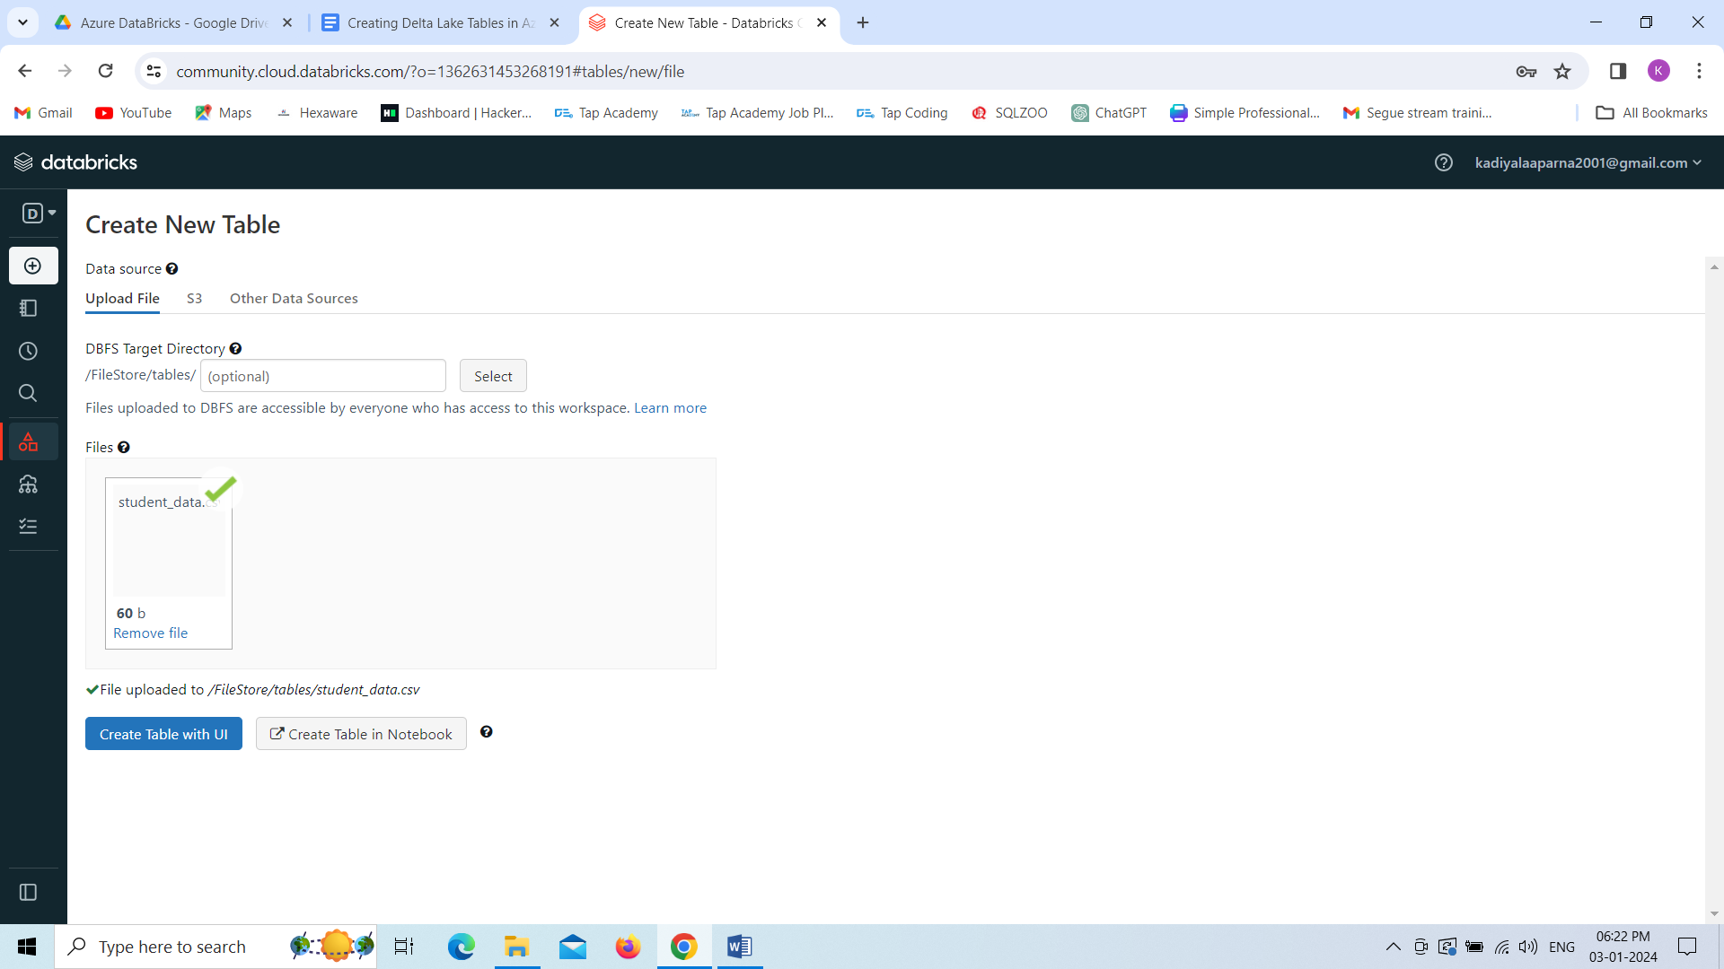

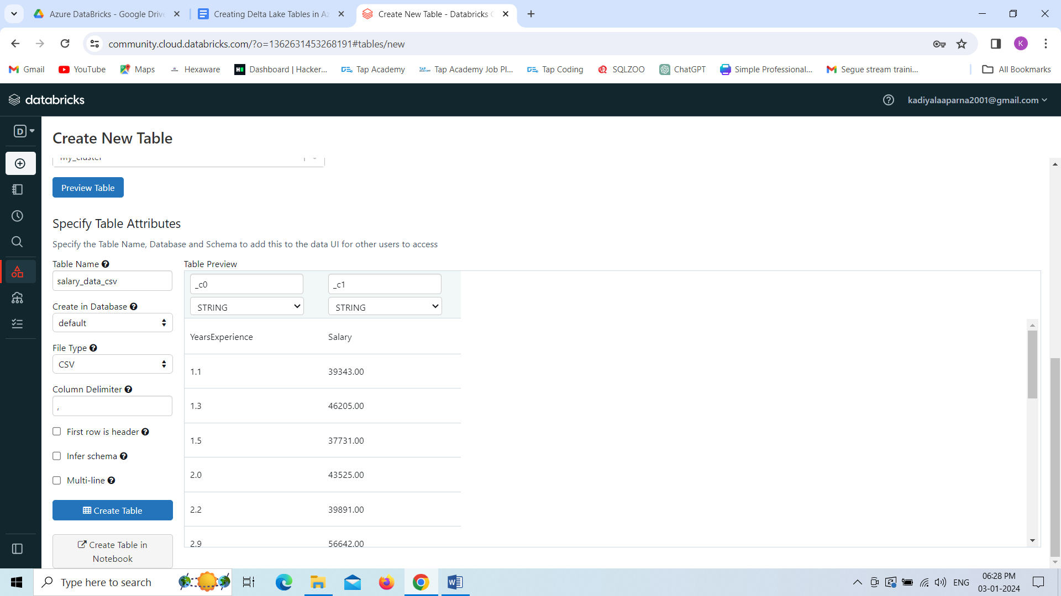

Finally, we created the datalake table with the sample data.

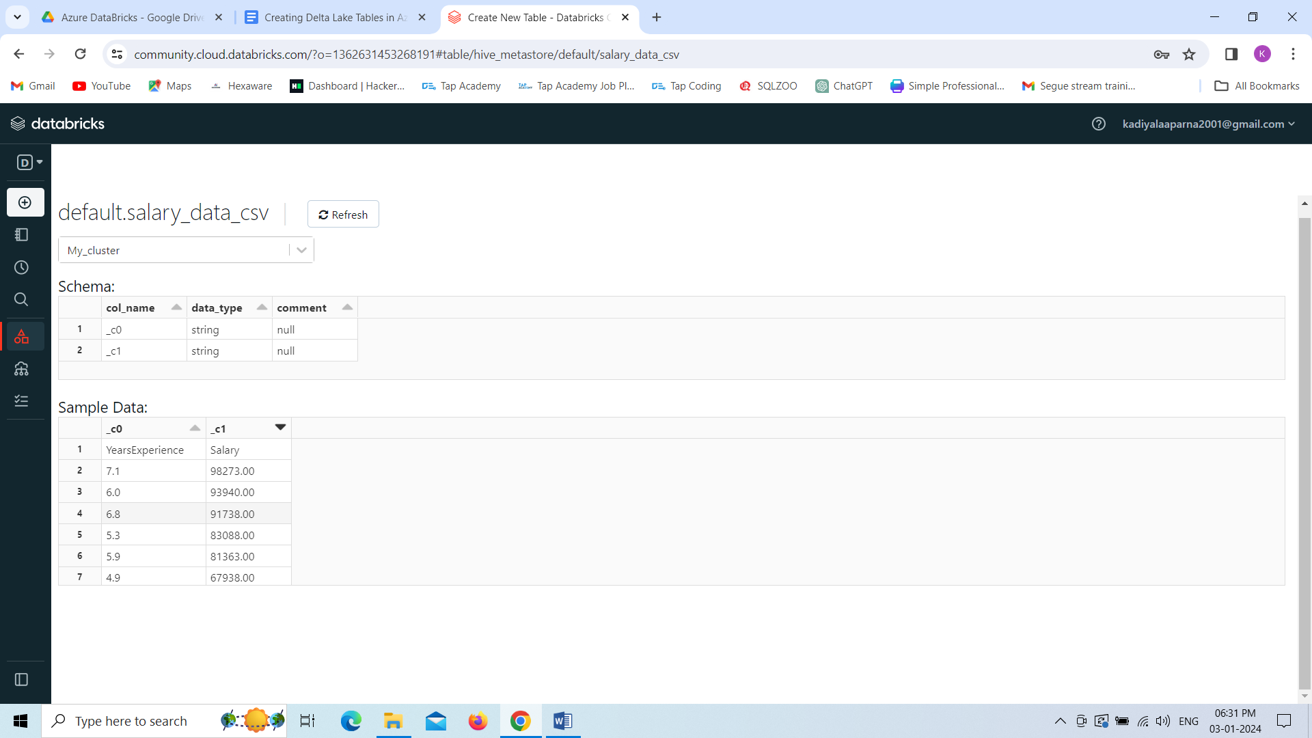

Now Creating Storage Gen2 in the Azure Databricks.

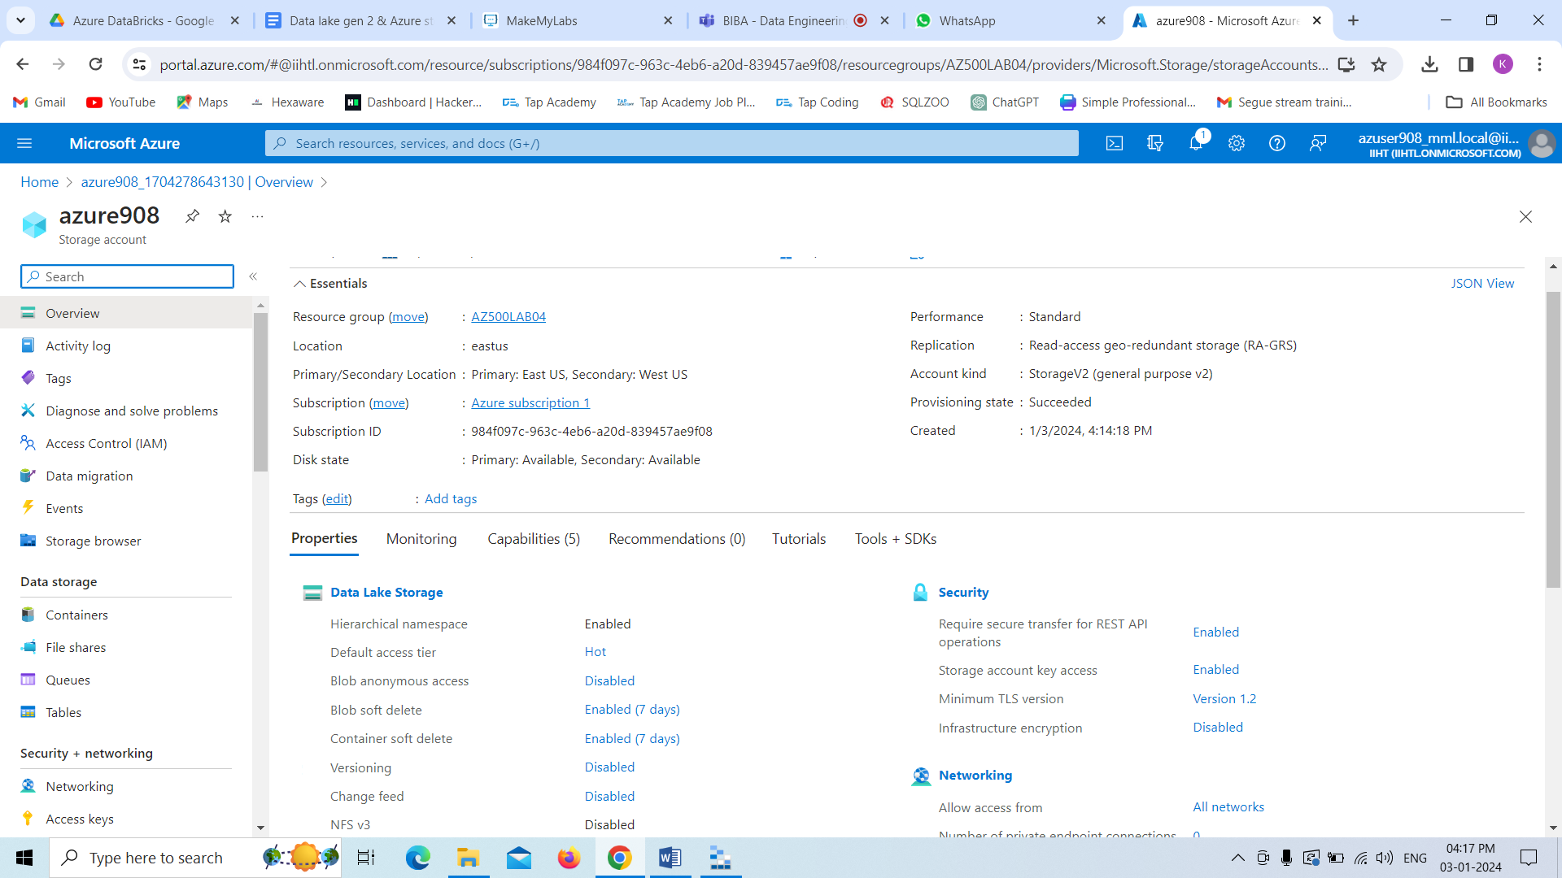

Now we have been downloaded and installed Storage Explorer in our local system.

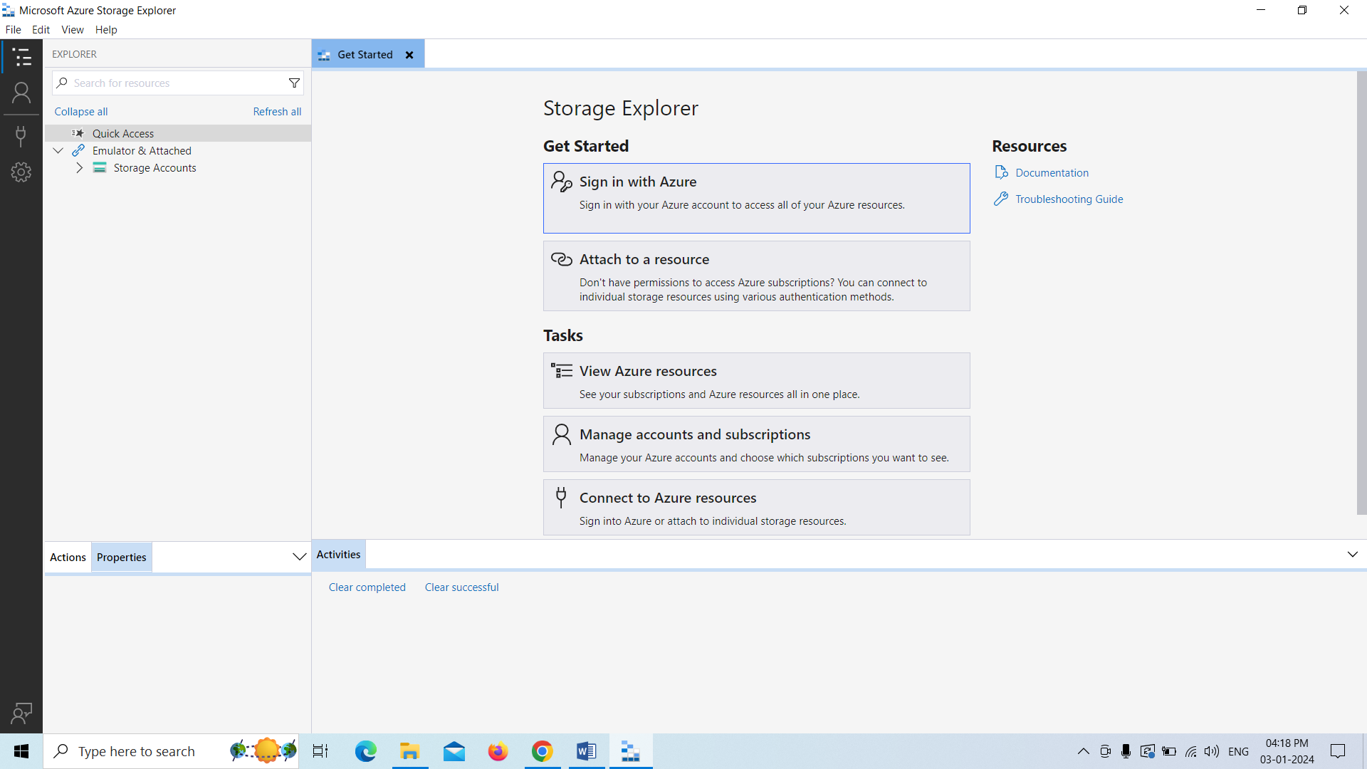

Now we need to connect our data storage gen2 with the storage explorer,Let’s see how can achieve the things as follows.

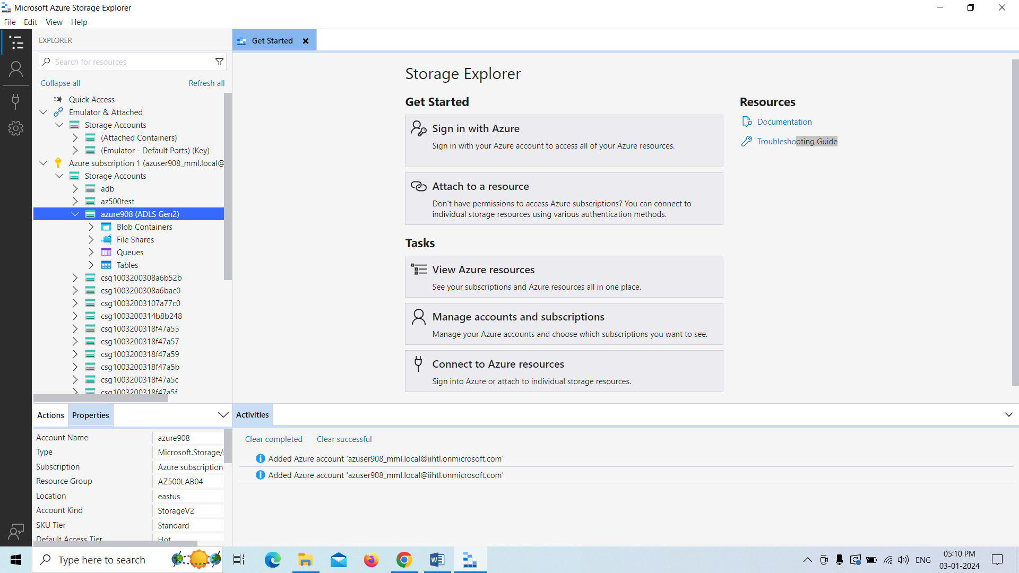

Now we need to create blob Container that will show our files in our local system.

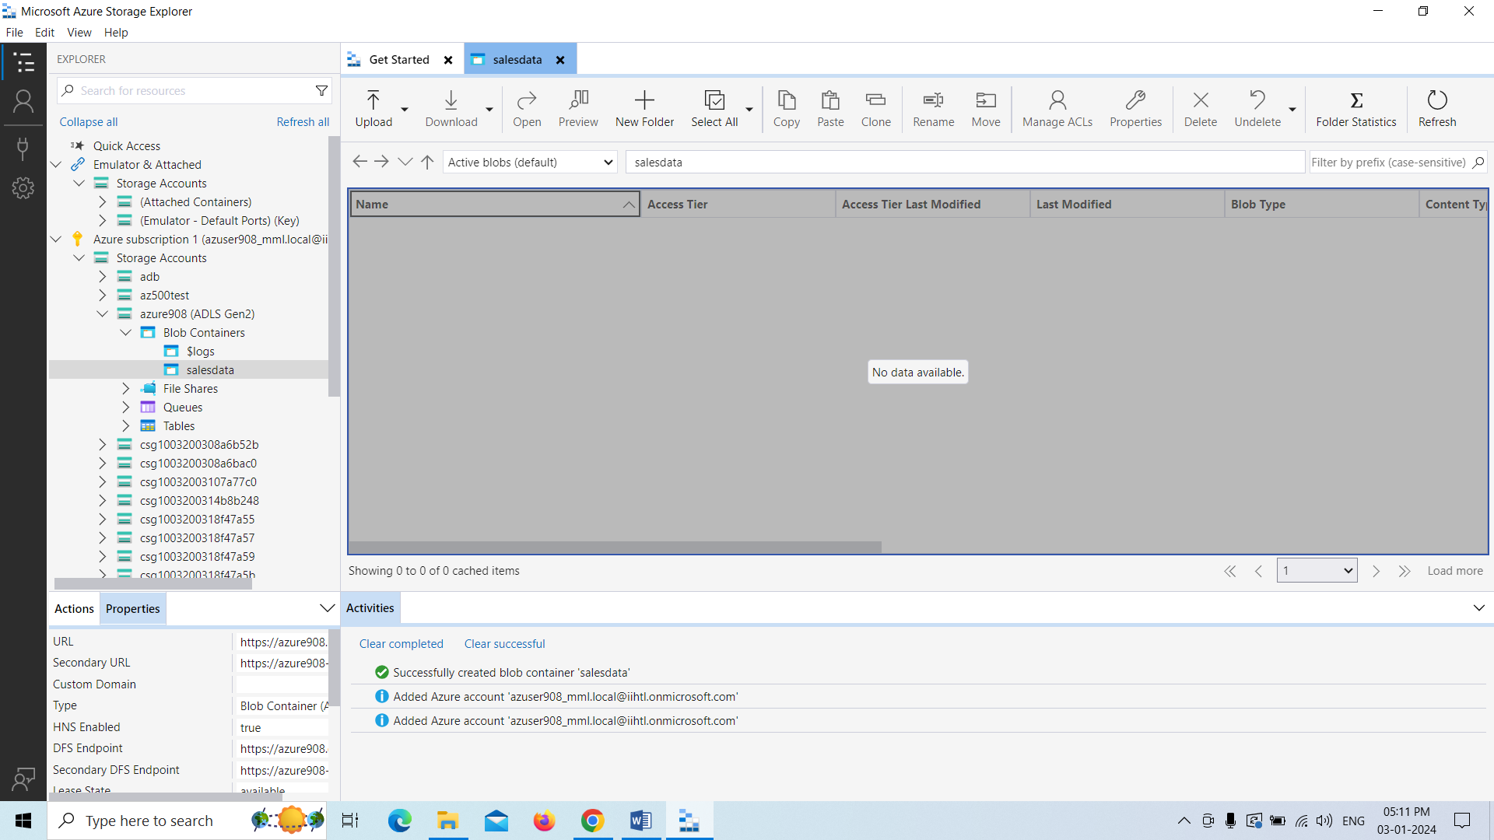

Here we are creating folder named as Sample for that particular folder.

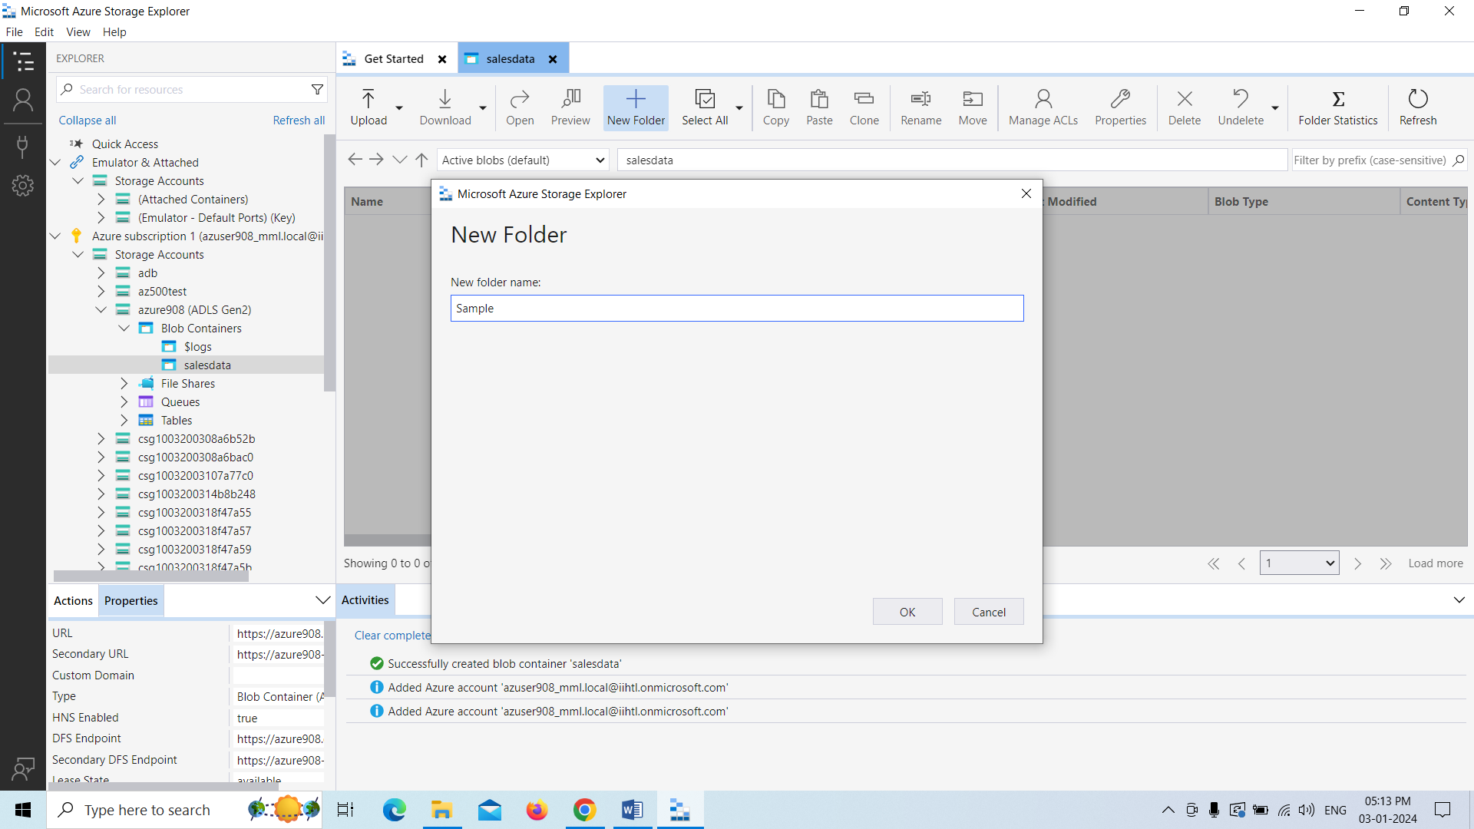

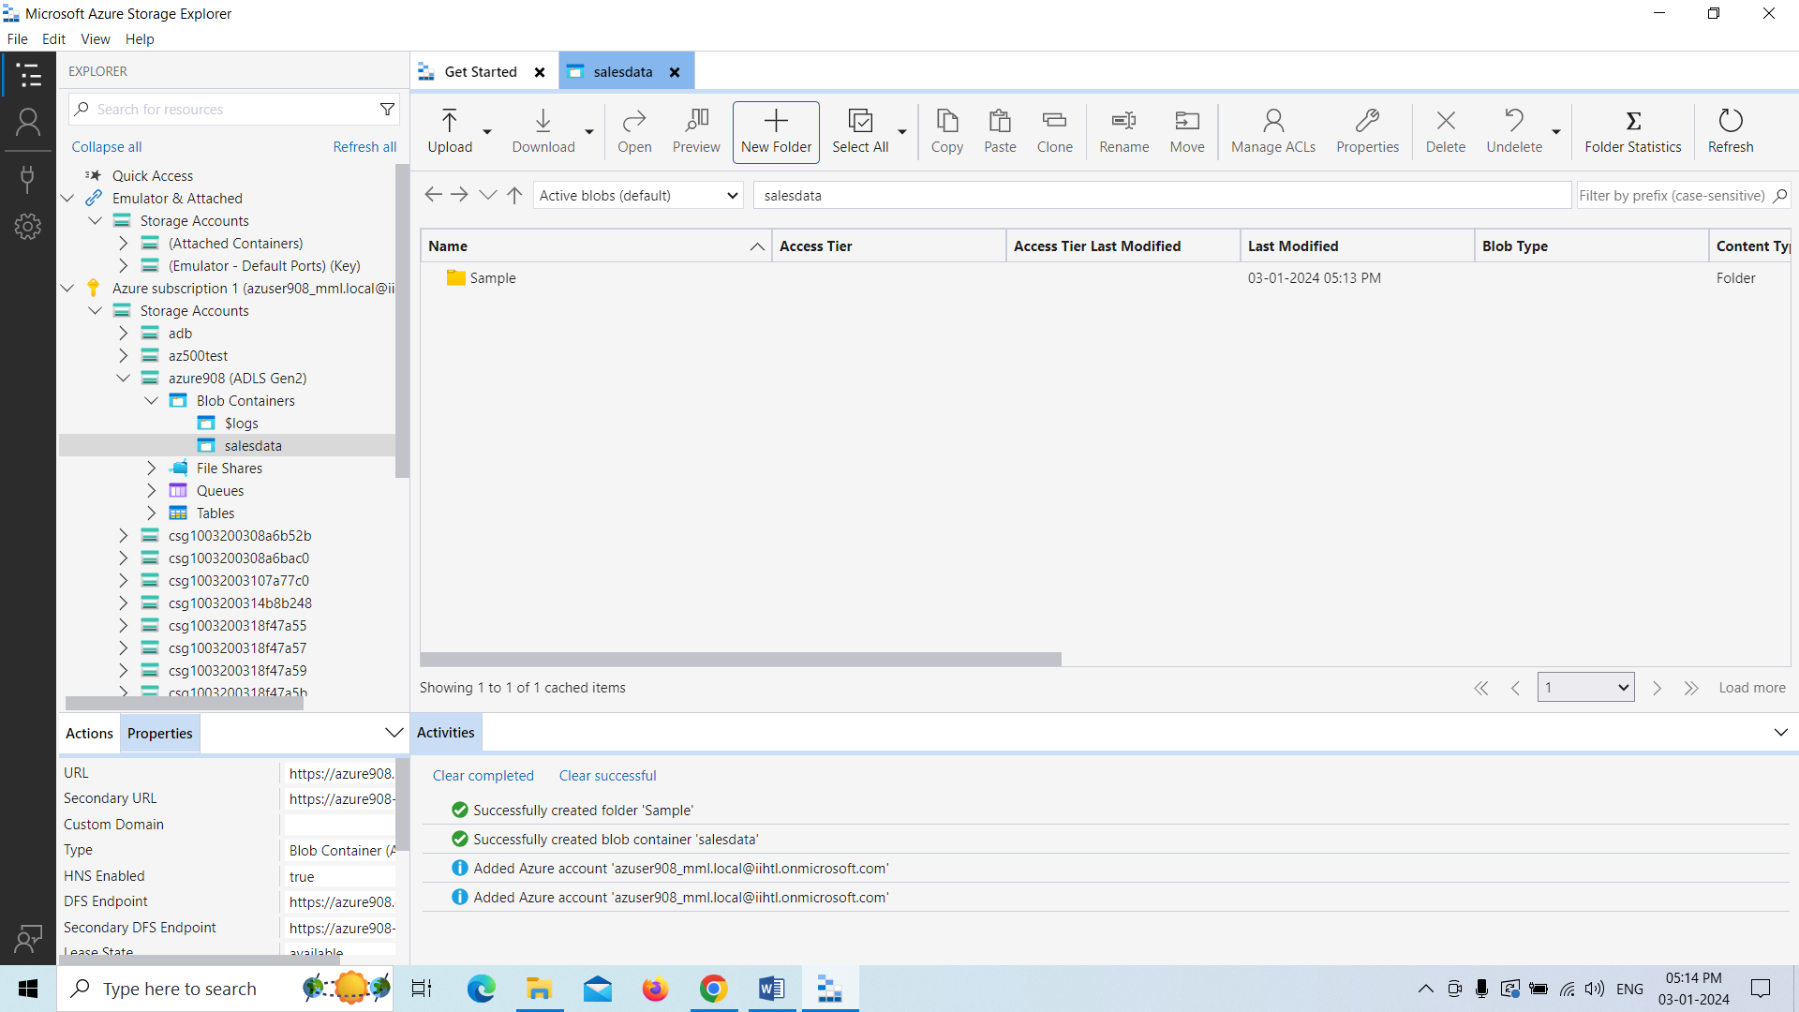

Creating another folder inside the sample folder named as data.

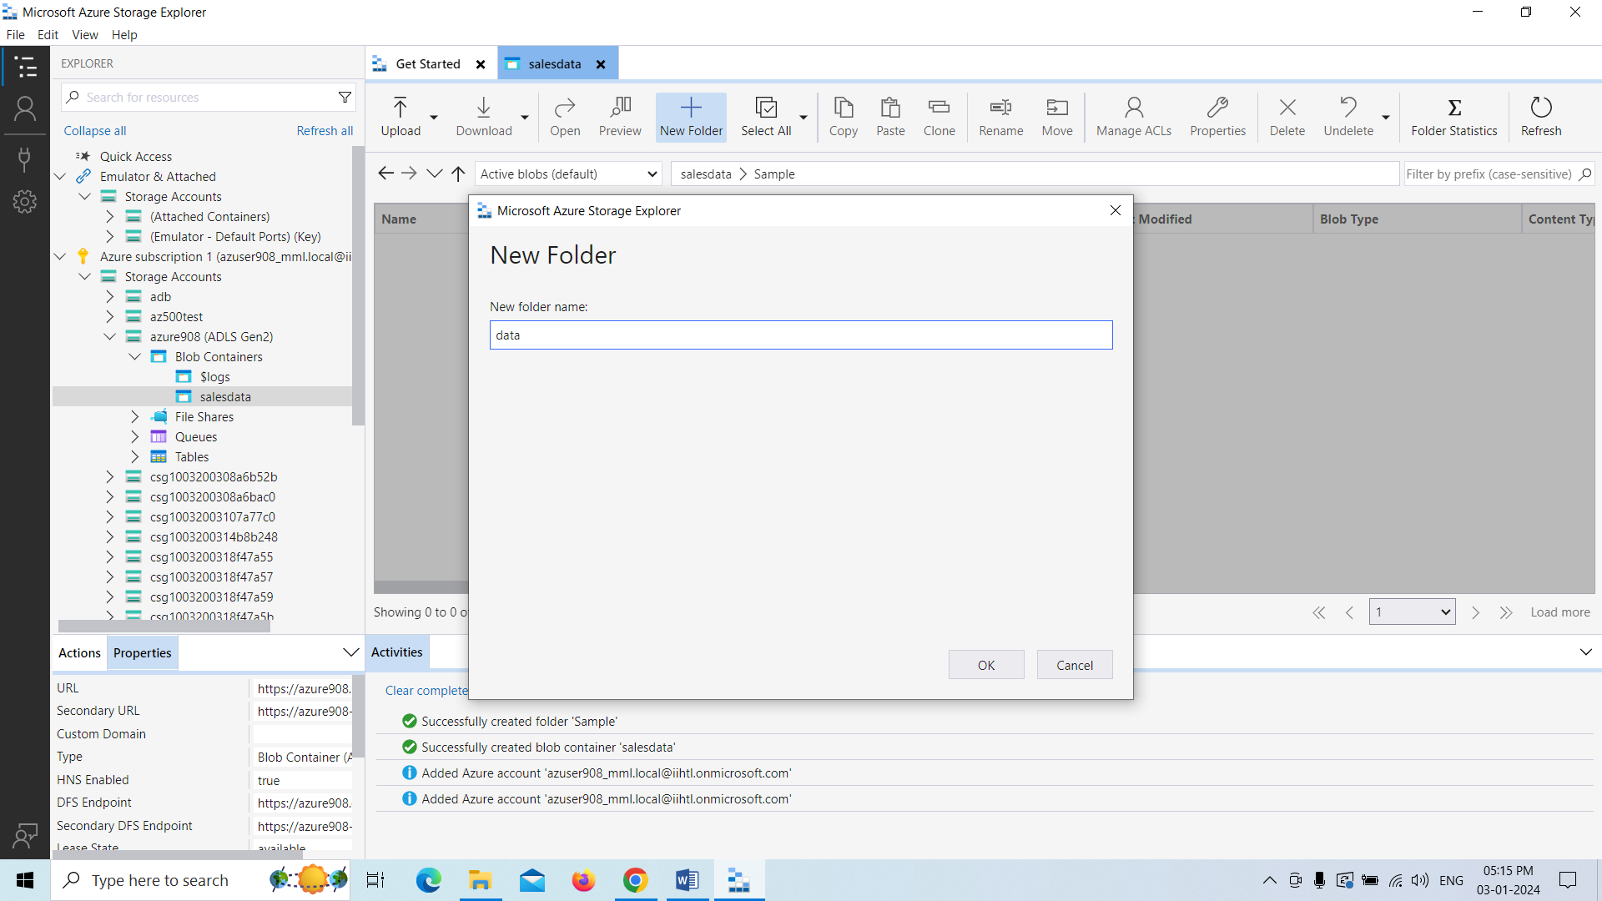

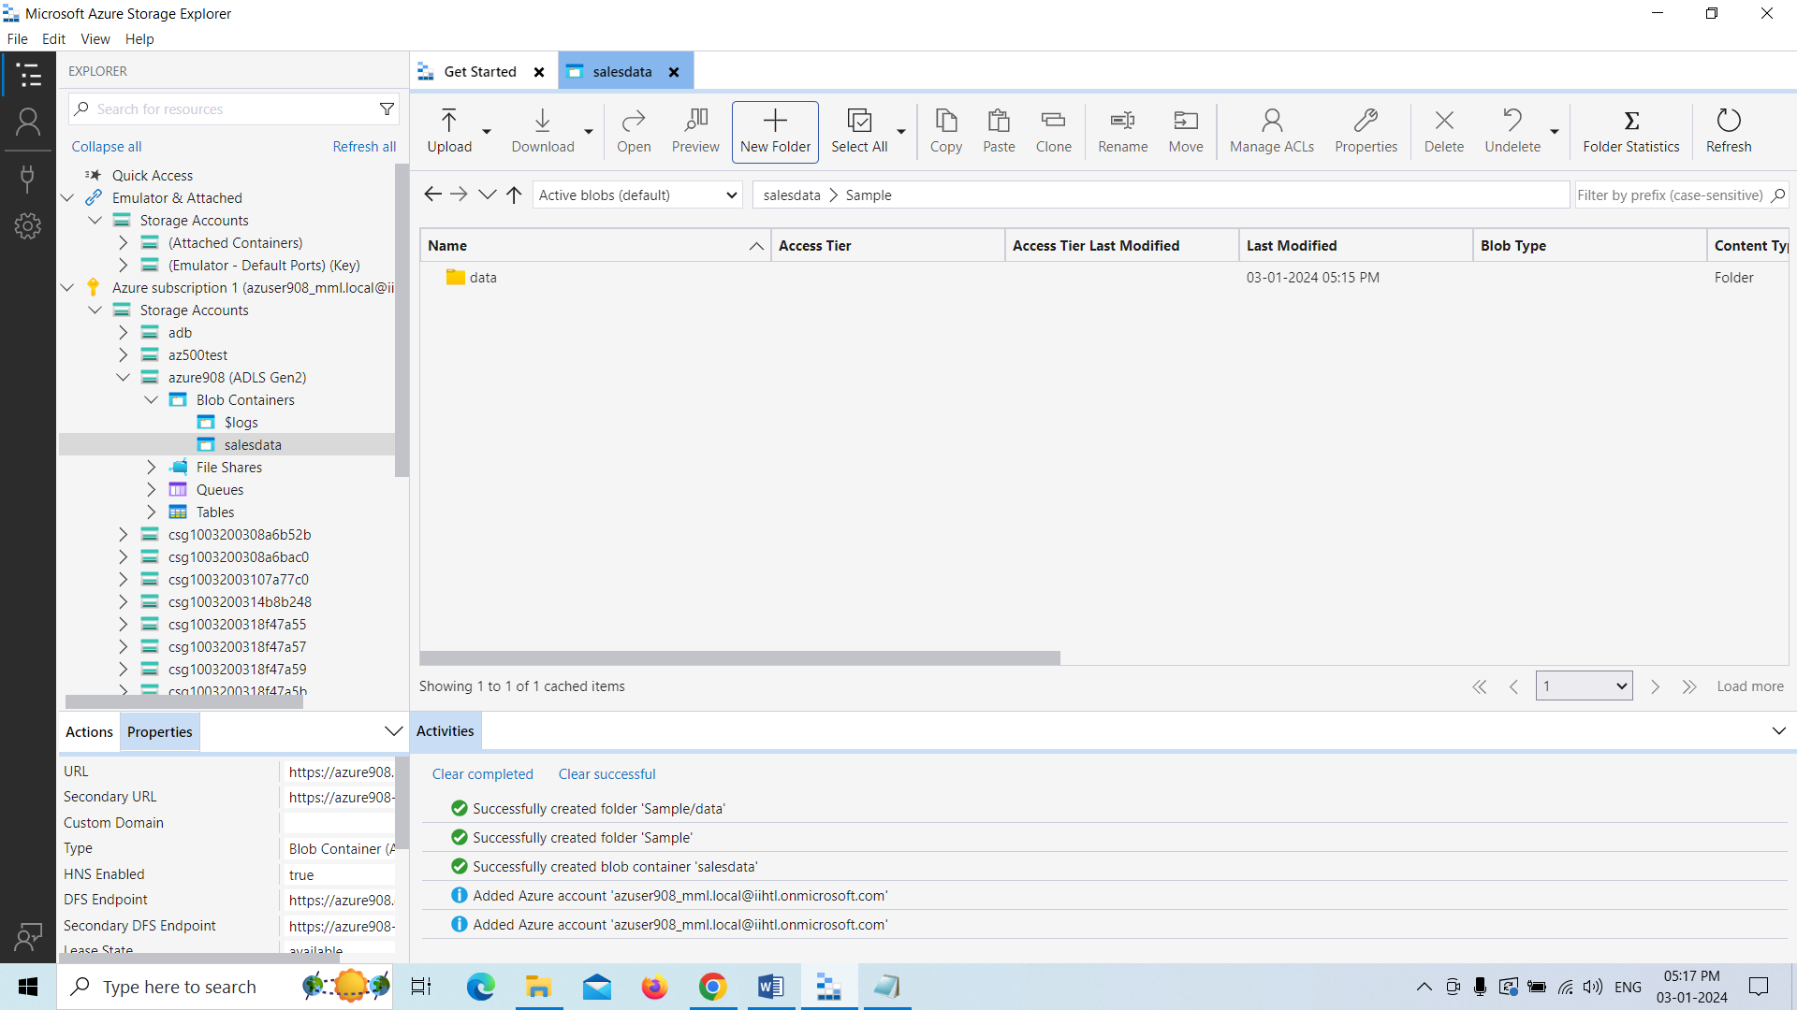

File is uploaded with the upload button that is present in our local computer.

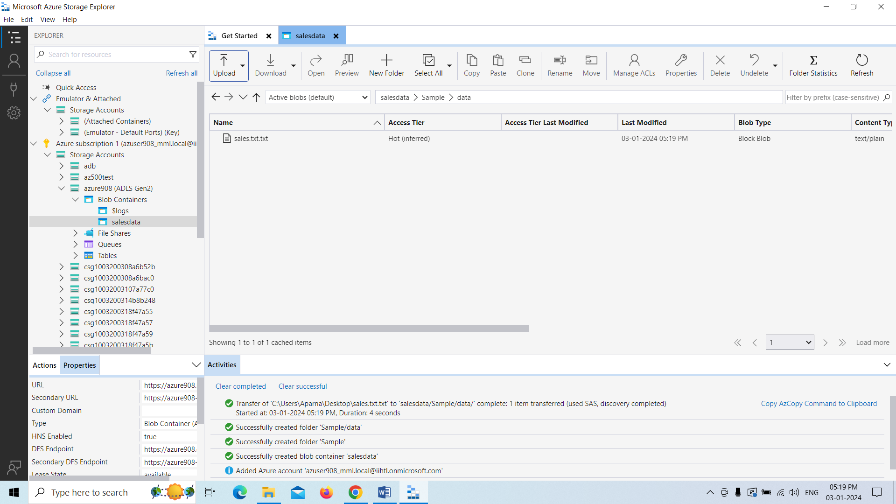

Finally those files are visible in our Azure Databricks.

